Ge:(array([ 3.75975741e-01, -3.66543765e+03]), array([[ 3.04808314e-01, -8.97244332e+01],

[ -8.97244332e+01, 2.64191301e+04]])) 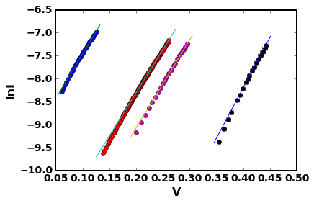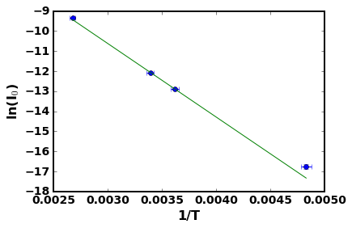

Si:(array([ 8.94798984e+00, -1.05151413e+04]), array([[ 8.39992767e-01, -2.99870982e+02],

[ -2.99870982e+02, 1.08157763e+05]])) 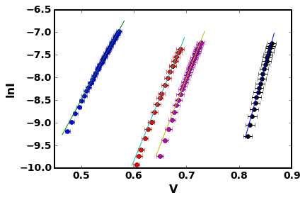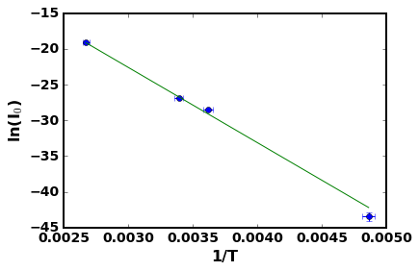

Eg(Ge)=0.31586

Eg(Si)=0.906

2nd run

Si: (array([-19.20671001, 21.42457655]), array([[ 0.01220261, -0.02231451],

[-0.02231451, 0.04081919]]))

(array([-27.45636521, 29.26755875]), array([[ 0.11553493, -0.17468415],

[-0.17468415, 0.26419665]]))

(array([-28.85306555, 29.78509683]), array([[ 0.06233907, -0.08790031],

[-0.08790031, 0.12395584]]))

(array([-44.24337326, 42.98010452]), array([[ 0.26774131, -0.31469263],

[-0.31469263, 0.36990487]])) 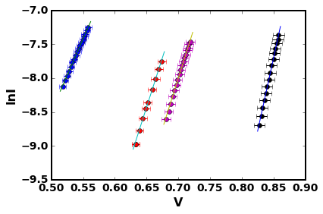(array([ 1.12879583e+01, -1.13432724e+04]), array([[ 3.24112553e+00, -9.65479544e+02],

[ -9.65479544e+02, 2.98929895e+05]])) 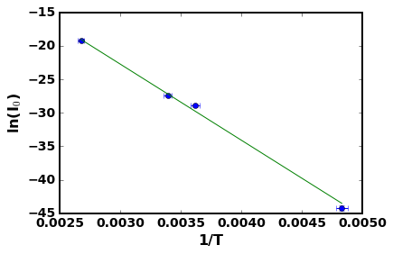

Eg(Si) = 0.977

Si 3rd run

[3:25] (array([-19.71302997, 22.36836563]), array([[ 0.0092008 , -0.01719252],

[-0.01719252, 0.03214341]]))

[6:22] (array([-28.70070849, 31.1835589 ]), array([[ 0.10467562, -0.16164681],

[-0.16164681, 0.24969738]]))

[3:11] (array([-32.96585515, 35.76357874]), array([[ 0.05233471, -0.07764347],

[-0.07764347, 0.11520755]]))

[4:20] (array([-46.46506507, 45.61556196]), array([[ 0.4195742 , -0.49819244],

[-0.49819244, 0.59159129]]))

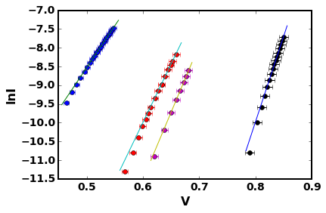

(array([ 14.09353643, -12689.30602025]), array([[ 3.93991667e+00, -1.18134192e+03],

[ -1.18134192e+03, 3.68530772e+05]])) 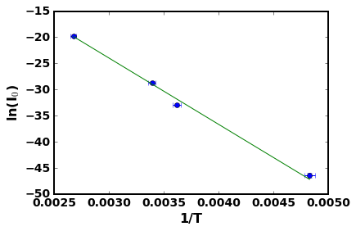

Ge(Si)=1.0934